

www.poran-a.com
Subscribe YouTube channel: Poran-A
Fashion Graphic Course will boost your career in RMG industries lifetime
Poran Sir
Fashion Graphic
With Adobe Illustrator



Course: Fashion Graphic with Illustrator
Mentor: Poran Sir
Class: 06
Topics: Creating a textile print design

- Download textile motif from Google

Open browser write Pinterest and search Textile Motif

Note: you should Select Repeatable solid & clear motif.

Motif link
https://www.pinterest.com/pin/280208408060839559/
https://www.pinterest.com/pin/267471665367625140/
https://www.pinterest.com/pin/487725834667051716/

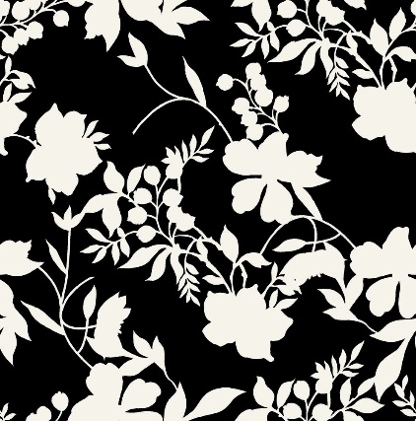
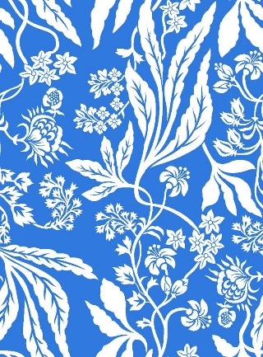
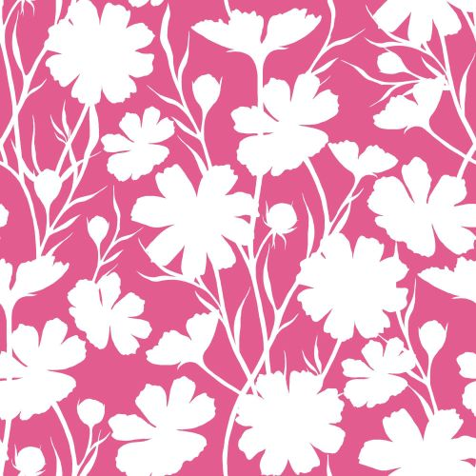

- Open Project file: Go to File > Open and select project file from your device
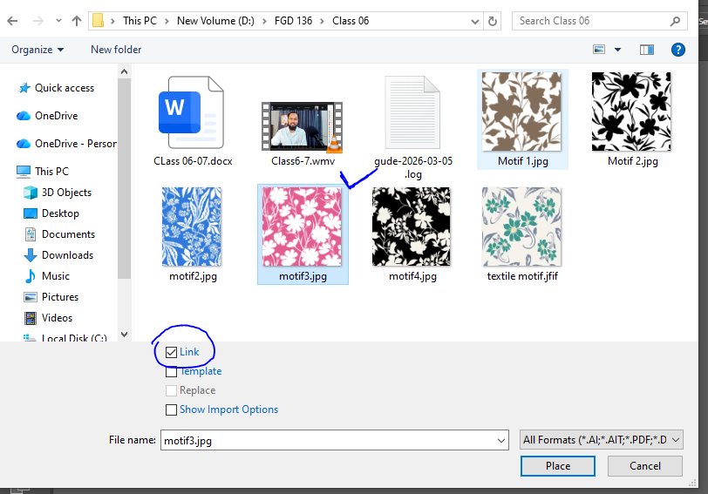

- Place motif: Go to File > Place
and select motif image from your device
Note: make sure uncheck link option

- Trace motif: Select motif click trace option

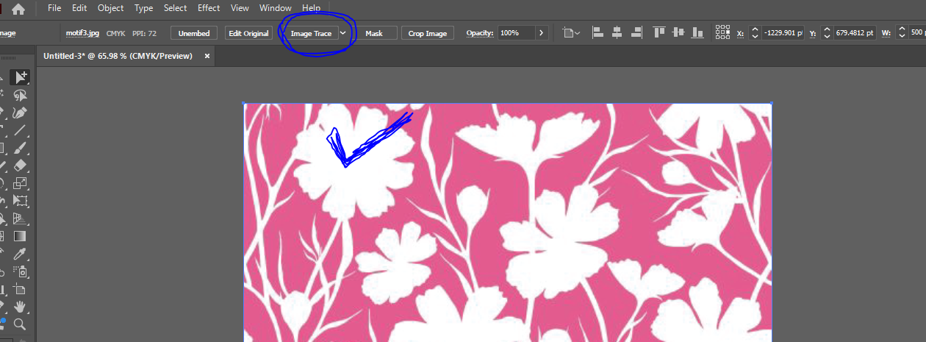

- click Image trace panel option to adjust trace level
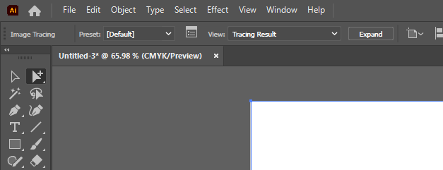
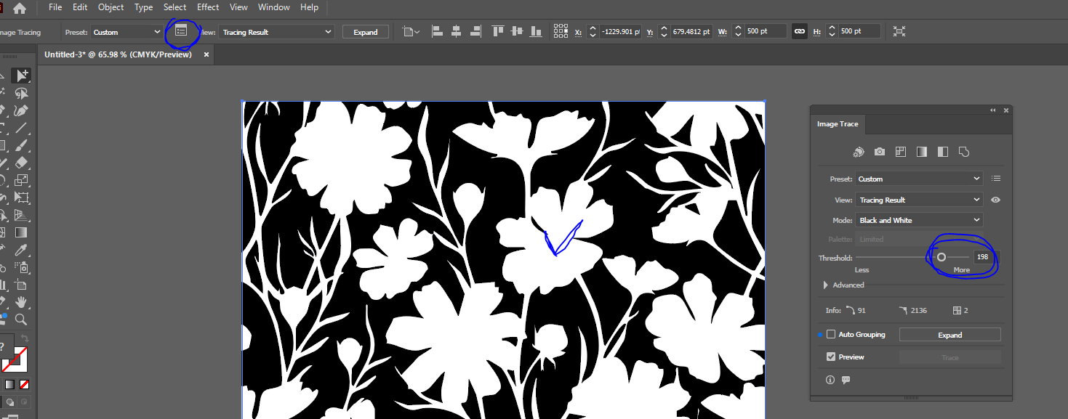

- Select magic want tool and change similar color

- Create Swatches with this motif

- Select group selection tool

- Select garment flat sketch specific object and apply swatches which you made

- Create Color way or color Compo design
copy the garment and apply other swatches

